JPE 2nd Grade Supply List
2022-2023

ALL STUDENTS:

$35 Student Operational Fee
**1 book sack-NO rolling or messenger styles
2 boxes of Kleenex tissues
JPE Meet the Teacher will be Monday, August 8, 2022 from 1-3pm.
Students return on Tuesday, August 9, 2022.
den
2 large rolls of paper towels
**1 composition notebook, wide ruled
**1 3 Subject notebook, wide ruled
**1 red PLASTIC folder with prongs
**1 green PLASTIC folder with prongs
**1 yellow PLASTIC folder with prongs
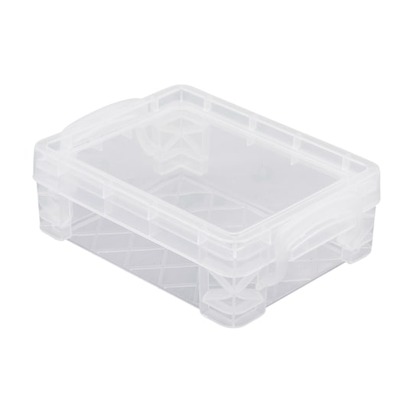**4 packs of Crayola crayons
**1 pack of Crayola colored pencils
**1 plastic storage crayon box (Outside Dimensions: 3.5 L x 4.75 W x 1.5" H)
**2 packs of Crayola markers (Classic – broad line)
**4 LARGE Elmer’s glue sticks
1 2-pack yellow skinny highlighters
**1 pair of ear buds or headphones
**1 pair of child scissors
**1 3-pack big pink rectangle erasers

Girls Only | Boys Only
1 box of gallon-sized Ziploc bags  3 (4 pack) of BLACK Expo markers (broad tip)  2 containers of disinfectant wipes | 1 box of quart sized Ziploc bags  1 pack of WIDE RULED loose-leaf paper  1 can of disinfectant spray  1 50 count paper bags
** Please write student name on supplies listed above that have ** by them.

