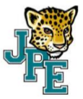
JPE Kindergarten Supply List
2022-2023
ALL STUDENTS:
(Please do Not Label Anything)****
$35 Student Operational Fee and Snack Fee - $35.00
*1 book sack-NO rolling or messenger styles
*1 red and blue (thin) rest mat
*1 pair of headphones (not earbuds)
*6 Black Expo Chisel Point Markers (no colors)
*6 packs of 24 count CRAYOLA crayons (no rose art)
*6 JUMBO ELMER’S glue stick – 1.4oz
*2 erasers (big and pink)
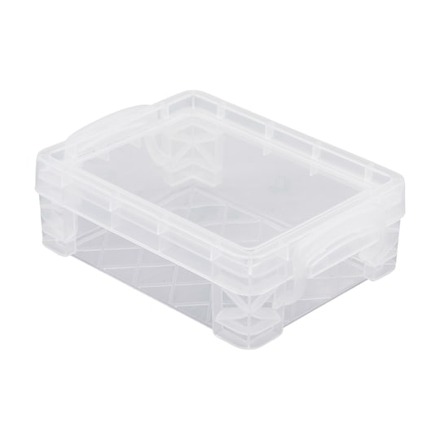*1 box of Kleenex
*2 rolls of paper towels
*1 plastic storage crayon box (Outside Dimensions: 3.5 L x 4.75 W x 1.5" H)
*1 container of Clorox wipes
*1 8 oz. bottle of hand sanitizer
*1 container of baby wipes
*1 pack of WHITE cardstock (not copy paper)
*1 WHITE 1”binder (pen & gear durable view)
*1 pack of white paper plates (uncoated)
*1 crayola washable watercolor paints
Girls Only | Boys Only
1 box quart Ziploc SLIDER bags  1 box of snack Ziploc | 1 box of gallon sized Ziploc bags  1 pack of white lunch bags

