**JPE 2nd Grade Supply List**

**2025-2026**

**ALL STUDENTS:**

$35 Student Supply Fee

*JPE* ***Meet the Teacher*** *will be Thursday, August 7, 2025 from 12:30-2:00 pm.*

*Students return on Friday, August 8, 2025.*

*1 book sack-NO rolling or messenger styles

*1 pair of child scissors

*1 3 Subject notebook, wide ruled

*3 big pink rectangle erasers

*3 packs of Crayola crayons

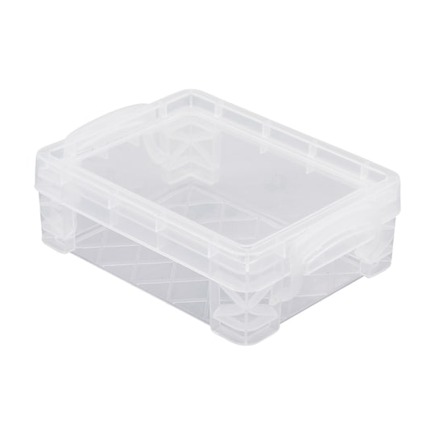

*1 plastic storage crayon box (Outside Dimensions: 3.5 L x 4.75 W x 1.5" H)

*2 packs of Crayola markers (Classic – broad line)

*4 LARGE Elmer’s glue sticks

*1 pair of headphones, NO earbuds (will need to replace throughout the year)

1 pack of white card stock

2 boxes of Kleenex tissues

2 large rolls of paper towels

2 yellow skinny highlighters

|  |  |
| --- | --- |
| **Girls Only** | **Boys Only** |
| 1 box of gallon-sized Ziploc bags  4 BLACK Expo markers (broad tip)  2 containers of disinfectant wipes | 1 box of quart sized Ziploc bags  1 can of disinfectant spray  1 box of baby wipes |

***Please write student name on supplies listed above that have * by them.***